Name:___________________________ Period:_______ __

Email address: ___________________________________

**Art** Home Learning Packet for all grades.

**Let’s play a game:** Your goal is to earn at least 80 points per week. Each page is worth a different amount of points based on how hard the project is.

* **Choose any assignments in the packet that you like.**
* **Make sure you have completed at least 80 points worth of projects per week.**
* **This is all or nothing – Meaning, you must put strong effort into each project. Either you will earn all of the points for the given page or none. I am very lenient but do want to see your best effort.**
* **Feel free to substitute other media – colored pencils, markers, crayons, etc. depending on what you have at home.**
* **Have fun and let this be a relaxing part of your day.**

**Elements of Art Principles of Design**

**10 Points**

**Elements of Art: Line, Shape, Color, Space, Form, Value, Texture**

Create a Mnemonic memory sentence to help you memorize the elements of art:

______________________________________________________________________________

Design each element word according to what it represents. For example "color"' would be written with colorful letters. Shape might be done with big block shape letter. Extra points for effort, creativity and design. Try to be neat and use the whole space. Materials: pencils, colored pencils, markers.

|  |
| --- |
|  |
|  |
|  |
|  |
|  |
|  |
|  |

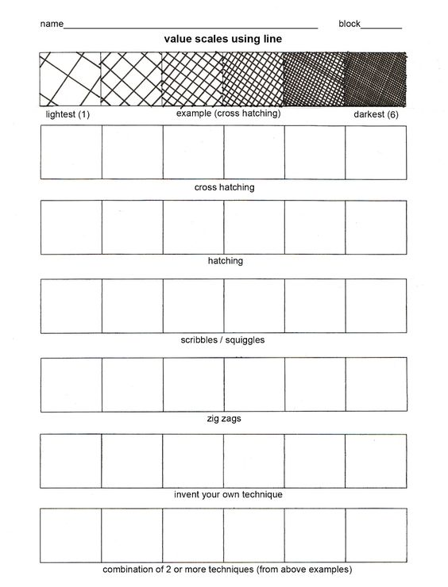**oints**

Create value scales by filling in the boxes of each scale with the correct type of mark. Go light on the left side and darker towards the right.

**5 Points**

**10 Points** 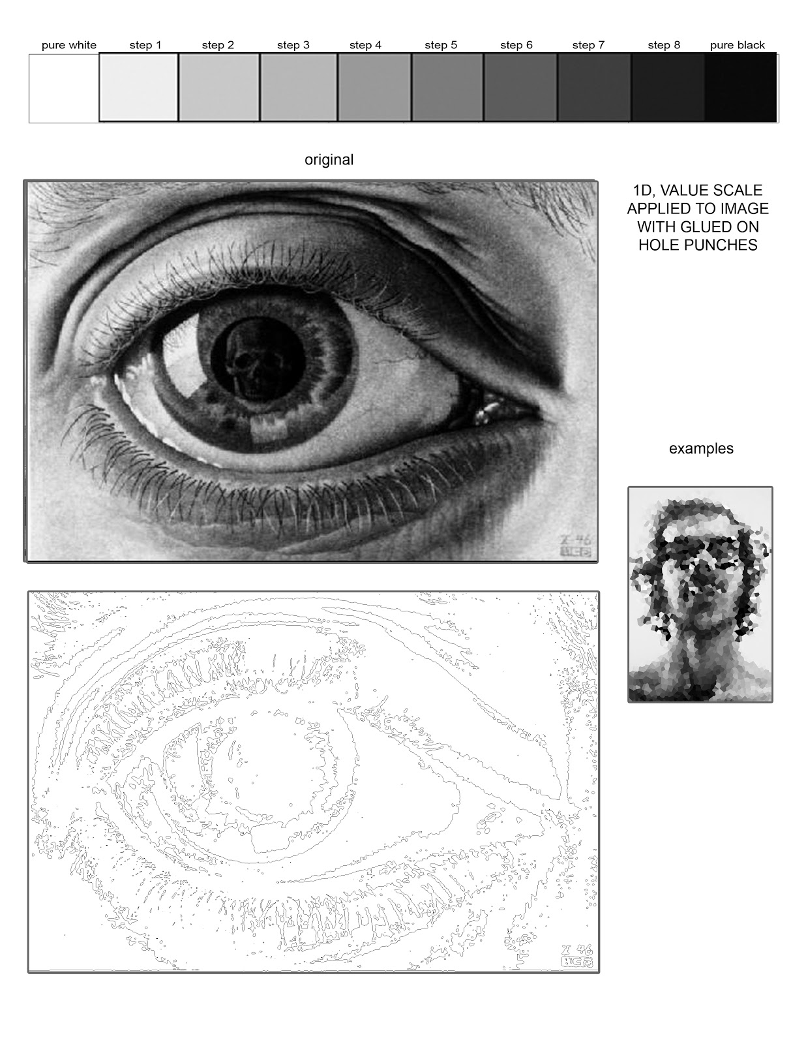

Copy the eye drawing from above in the box to the left. The outline is already there. Just try to fill in the correct values.

**20 Points**

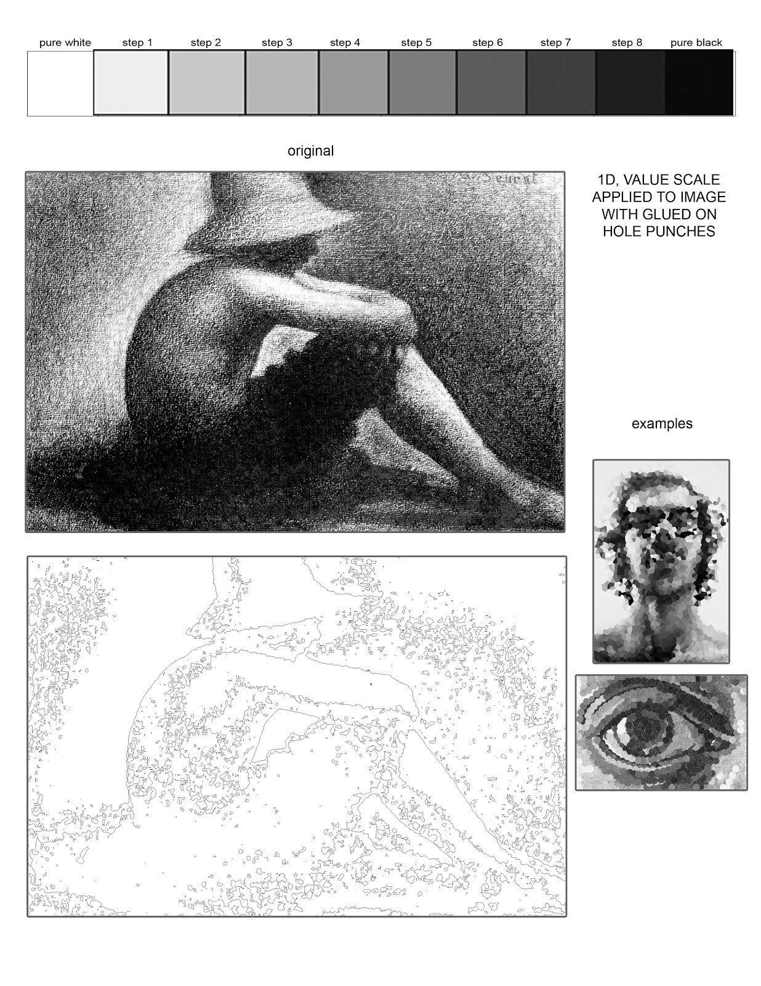

Copy the drawing from above in the box to the left. The outline is already there. Just try to fill in the correct values.

**20 Points**

**Principles of Design: Pattern, contrast, balance, unity, movement, rhythm, emphasis.**

**10 Points**

Create a mnemonic memory sentence to help you remember the principles. They do not have to be in any order: ______________________________________________________________________________

_____________________________________________________________________________

Pattern Definition: (may use a dictionary for help)

______________________________________________________________________________

______________________________________________________________________________

Using colored pencils or markers, create an interesting pattern inside the grid and circle.

Contrast Definition: (may use a dictionary for help) ______________________________________________________________________________

**10 Points**

______________________________________________________________________________

Shade in the flower using high contrast, low contrast, medium contrast, and high contrast.

Your choice (high contrast)

Two colors (medium contrast)

Different values of one color (low contrast)



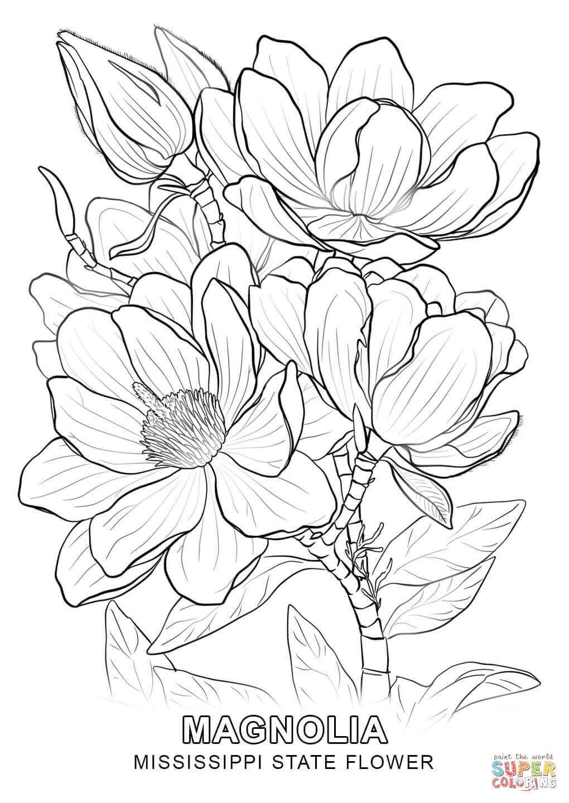

Balance definition: (may use a dictionary for help) ______________________________________________________________________________

**15 Points (page 8 + page 9 = 15)**

______________________________________________________________________________

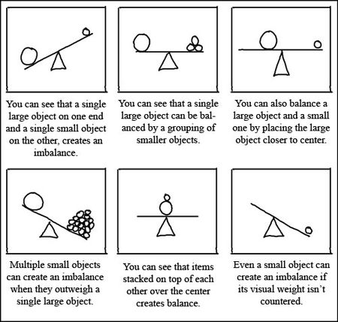

Draw an example of each form of balance

|  |  |  |
| --- | --- | --- |
| Radial | Symmetrical | Asymmetrical |

Create an interesting abstract design that emphasizes one of the types of balance (see page 8).

See the artwork of [**Kandinsky**](https://www.wassilykandinsky.net/) for inspiration.

Which type of balance did you choose? ______________________________

Unity Definition: (use a dictionary for help) ______________________________________________________________________________

**5 Points**

______________________________________________________________________________

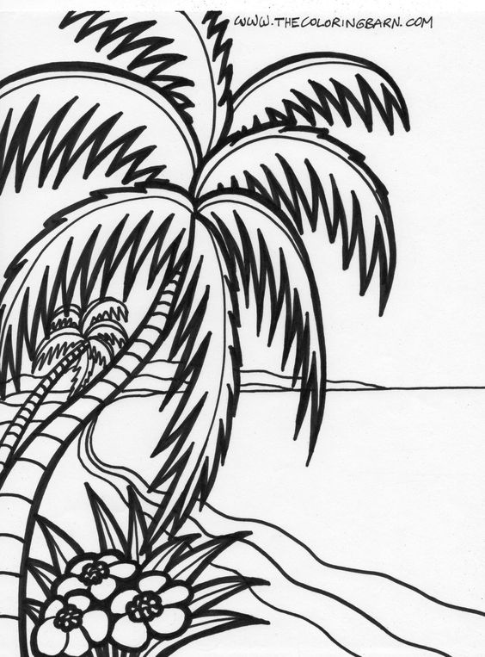Use colored pencils to color this page using unifying colors.

Movement Definition: ______________________________________________________________________________

**10 Points**

______________________________________________________________________________

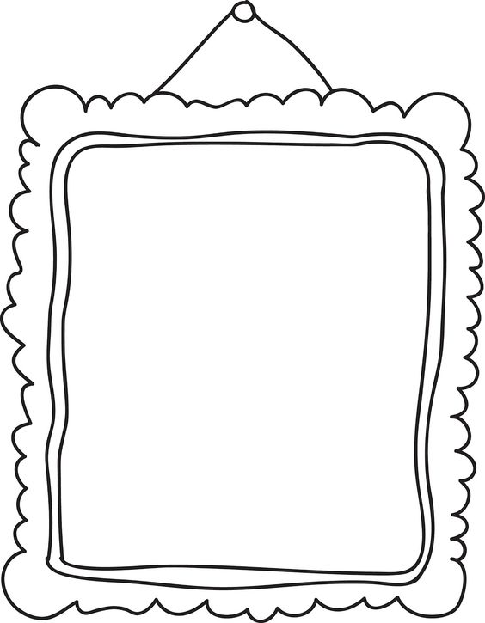Draw a tree in a way that emphasizes the principal of movement.

Rhythm Definition: ______________________________________________________________________________

**15 Points**

______________________________________________________________________________

Below are some examples of artworks with a strong sense of rhythm. On the next sheet of paper, create design that has a sense of rhythm.

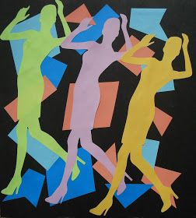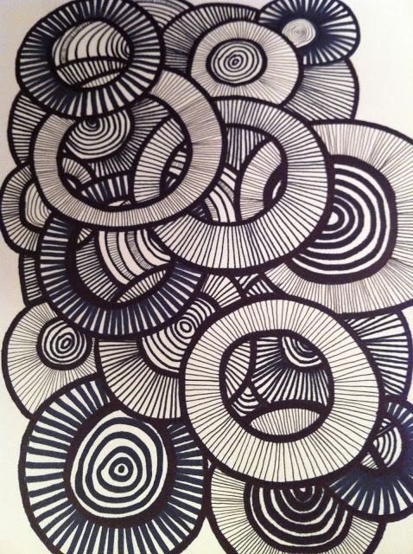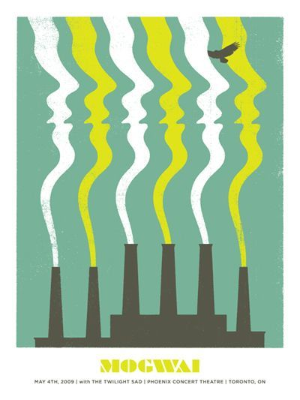

Rhythm

Emphasis Definition: ______________________________________________________________________________

**5 Points**

______________________________________________________________________________

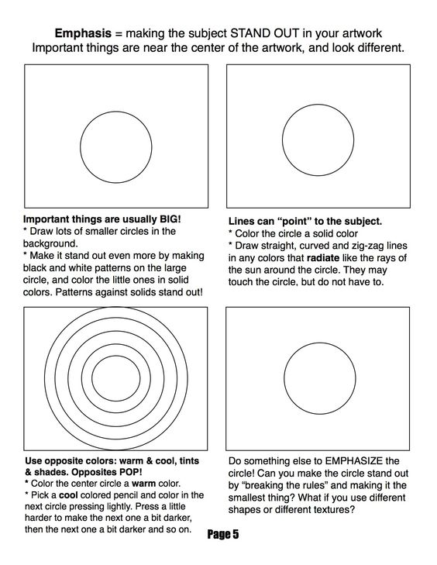

Copy this photograph using graphite pencils for the ceramic pieces and background. Use Colored pencil to draw in the apple. **What elements and principles of design might this drawing demonstrate and why? __________________________________________________________________________________________________________________________________________________________________________________________________________________________________________**

**40 Points**

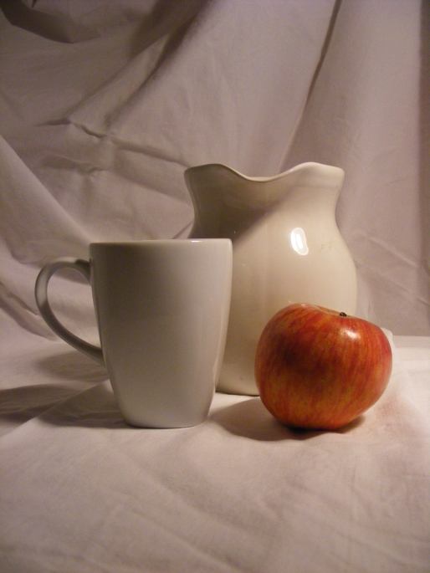

Apple Drawing (Color just the apple with colored pencils. Use black graphite pencils for the rest)

Fill in the color wheel using colored pencils. Tints on the outside wheel, the true colors on the middle wheel, and shades towards the center. You can leave the exact center empty or color black. **Neatness counts!** *(Tints are when you lighten a color with white. Shades are when you darken a color with black)*

**10 Points**

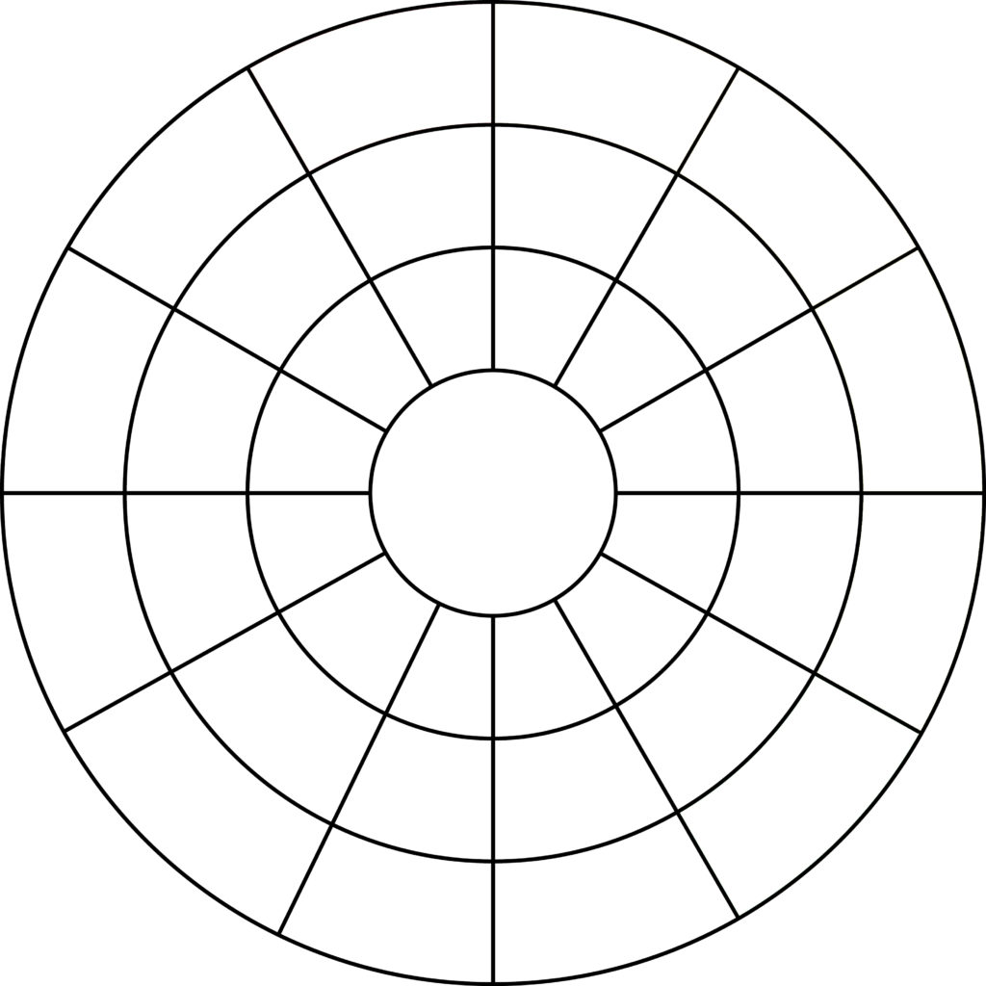

Shade

Tint

Red Orange

?

Blue

Violet

Green

red

**Five points extra credit! Color in the optical illusion using cool colors on the sides and warm colors on the tops of the rectangles. +5pts**

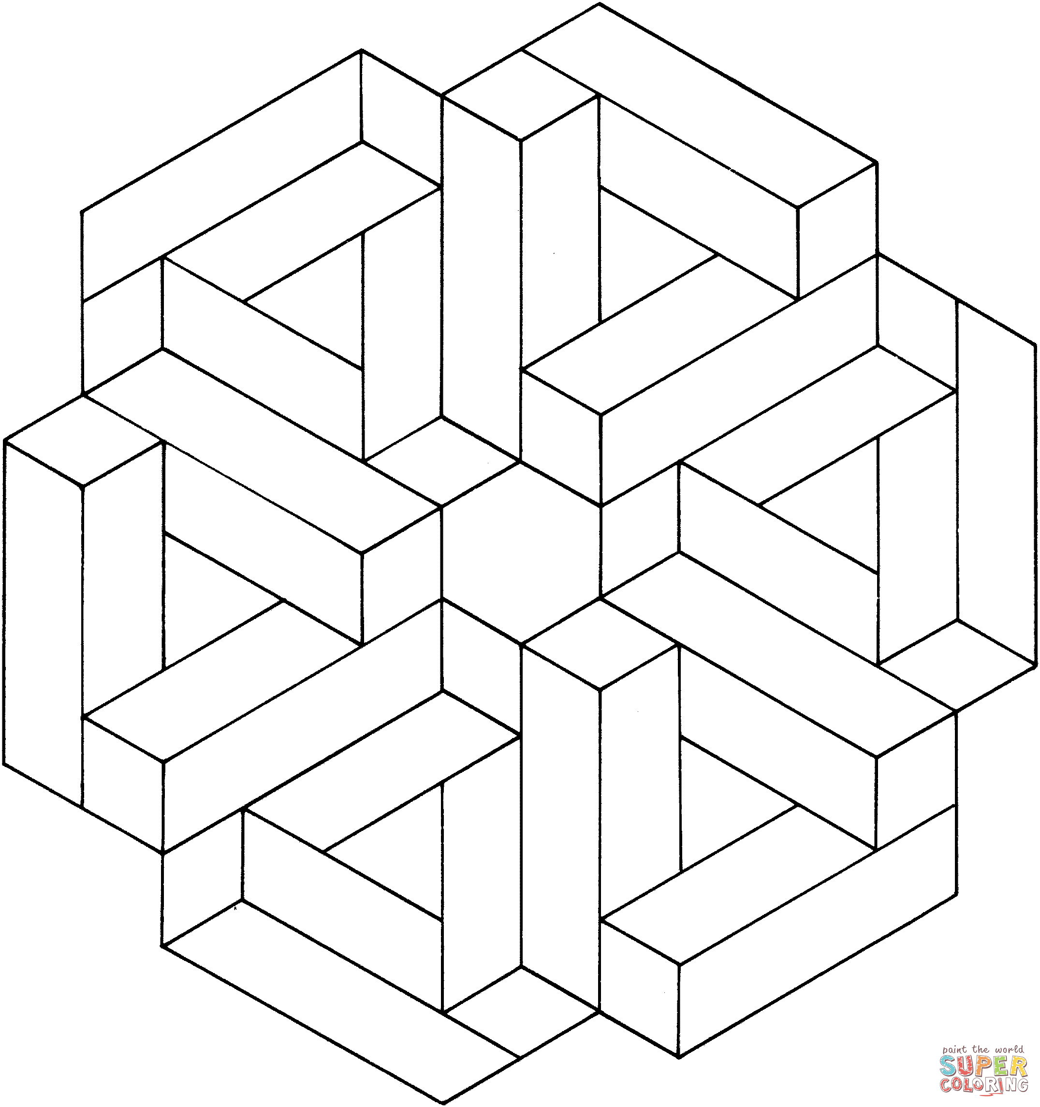

Find a picture of an insect in black and white. Then use a light pencil to carefully draw and enlarge your insect in your sketchbook (no shading). Finally, use a fine point sharpie to shade in the values. Alternatively, you can use stippling (lots of tiny ink dots) to shade in the insect.

**20 Points**

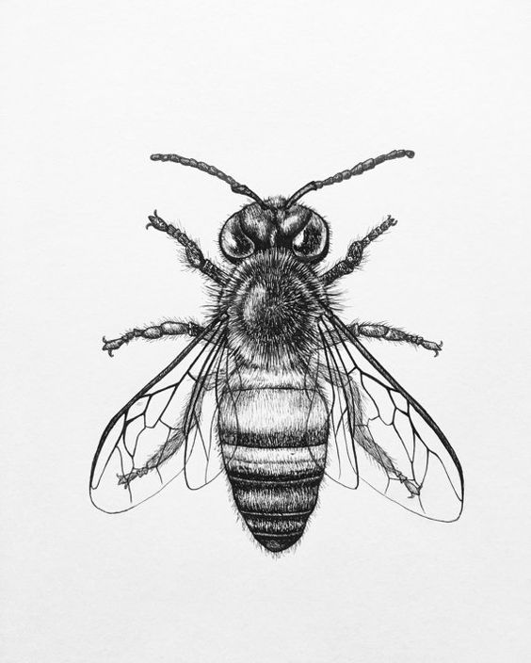

**Scribbled Sheep:** Use a pencil to make only a few initial lines to get the basic proportions of the sheep. Then switch to a fine tip sharpie and create a loose scribbled drawing of the sheep. Let your scribbles pile up to create darker areas and try to use the whole page of your sketchbook.

**15 Points**

**Extra Credit:** Do the same assignment again with a different animal. +5pts.

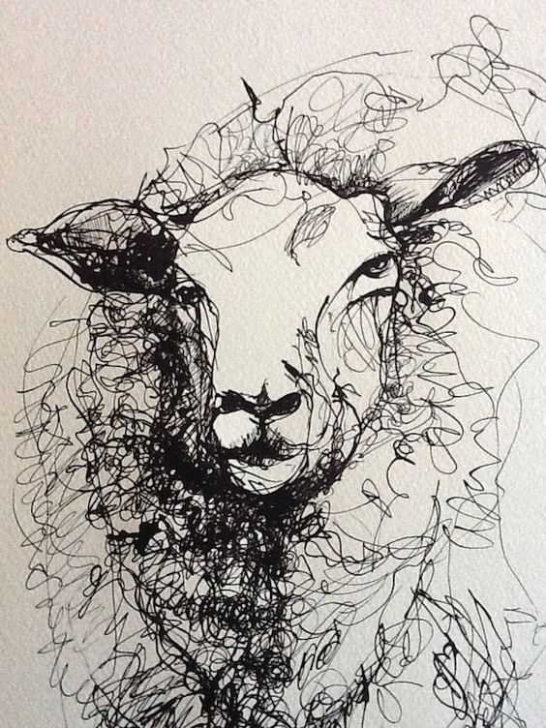

Copy M.C. Escher's drawing of hands. Begin with a light contour line drawing and then shift into a value drawing on the hands part.

**40 Points**

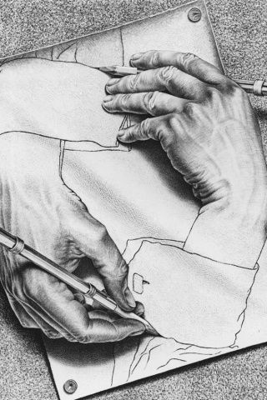

**Scribbled Face.** Find a photo or look in the mirror. Using a scribbled line, begin to scribble in the darker areas with more dense scribbles and the lighter areas with more open scribbles. See if you can create face.

**15 Points**

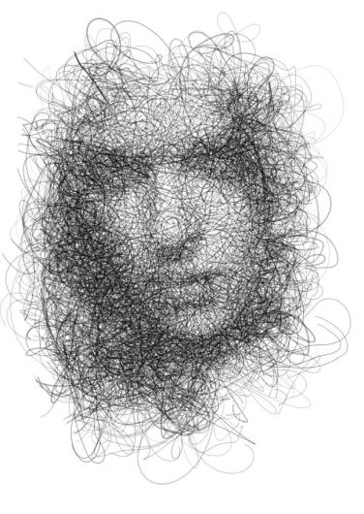

**A Face of Patterns:** find an interesting black and white photo of a face. It does **not** have to be this one. Then, using the grid method, enlarge the photo onto a sketchbook page. Finally, using either markers, colored pencils, or fine tip black sharpie, create patterns in each of the grids you have created. Use patterns that are dense and dark to fill in the shadows and darker areas. Use more open (lighter) patterns for soft areas and background areas.

**40 Points**



                
                
                
                
                
                
                
                
                
                
                
                
                